TITLE IN UPPERCASE LETTERS, TIMES NEW ROMAN (TNR),
BOLD, 14, JUSTIFICATION CENTER
Authors N. Surnames, TNR, 14, regular, center
Organization TNR, 12, center
E-mail of corresponding author, TNR, 12, center

There should be an indent after title (6 pt).
The surname of reporter should be underlined in the authors list.
After e-mail there should be an interval prior to the main section (10 pt).
The main text should be placed in two columns. TNR, regular, 11, single line spacing. Auto division of words is possible. It is not recommended to divide an abstract into parts (introduction, materials and methods, results, discussion).
A text should fill one or two full pages. Free lines in the end of the document are not possible.
Margins: 3 cm left, 1.5 cm right , 2 cm top and bottom. A space between the columns should be 1.25 cm. First line indentation should be 0.5 cm.
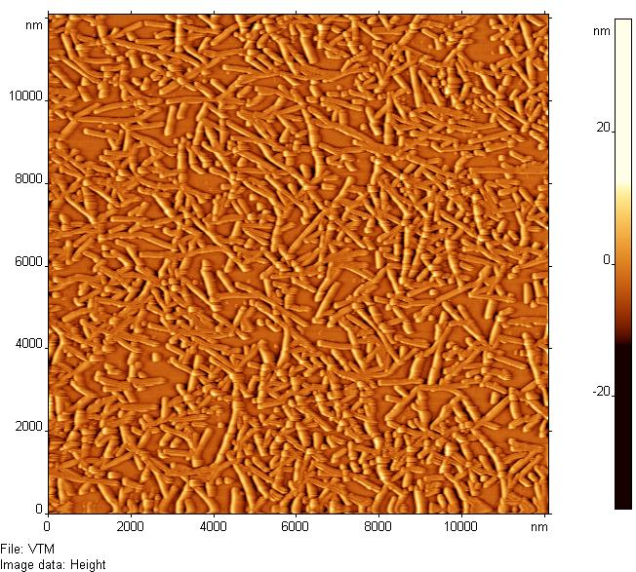
Figure inscription in the text should have 5 pt indents from top and bottom.

Fig.1. Inscription
You can use italic font to emphasize something.
References should be adduced in the end of abstract as a numbered list. In the text you can refer to them using numbers it square brackets [1]. You should leave a gap between main text and list of references 6 pt.
You should conform to these rules. It is necessary.
Experienced users of Microsoft Word can enjoy styles containing in this file. (Styles and Formatting).
- Title ⎯ AS_Heading 1
- Authors list ⎯ AS_Authors
- Organization ⎯ AS_Organization
- E-mail ⎯ AS_Mail
- Main text ⎯ AS_Main Part
- Element of numbered list ⎯ AS_list
- Title of list of references ⎯ AS_bibliography
- Emphasize words ⎯ AS_Main Part +Italic
- Underlined surnames in authors list AS_Authors +Underline.
Fig. 2. Inscription
You should also draw attention to the appearance of items in reference list. An example of correct typography is given in the end of this document.
We will be obliged if you pay attention to these rules. It can make our work much more pleasant. Thank you.
Reference List:
- Surname N., Surname N., Journal, №, pages 100-110 (year).
- Surname N., Book title, city, publisher, year.

